FLEXBOX

1. Definition

Flexbox is a one-dimensional CSS layout that can control the way items are spaced out(ditempatkan) and aligned(disejajarkan) within a container(wadah).

[ display: flex; ]

This will make the element a flex container(wadah fleksibel). Any direct children(turunan lgsg) of a flex container are called flex items(item fleksibel).

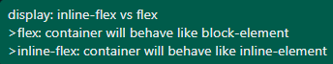

1. Flex Properties

Source: <https://www.freecodecamp.org/news/the-css-flexbox-handbook/>

Simple explanation (these images below):

1. Flex Container Properties

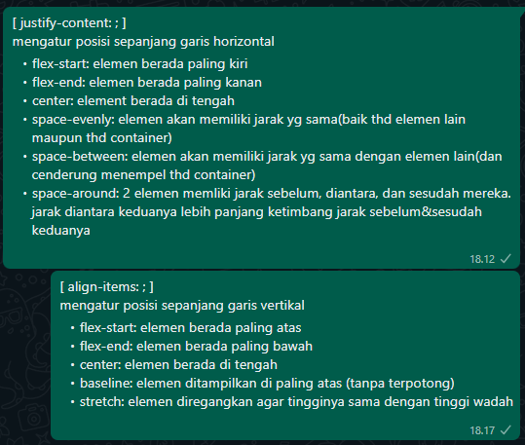

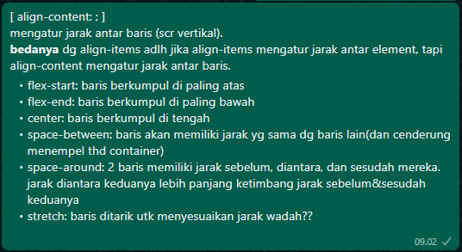

1. Flex Items Propeties

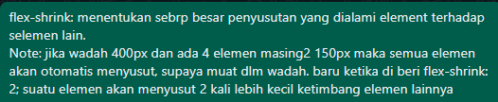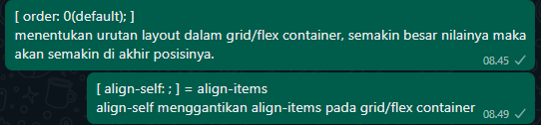

Note: Pelajari flex grow; shrink; basis dari Scrimba

[ flex: 1; = flex: 1 1 0; ]

[ flex: auto; = flex: 1 1 auto; ]

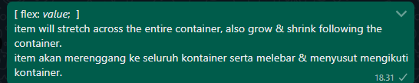flex-basis: auto; artinya lebar element tersebut sama dengan lebar textnya.



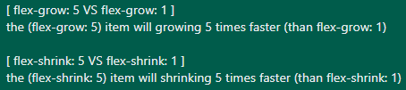

1. 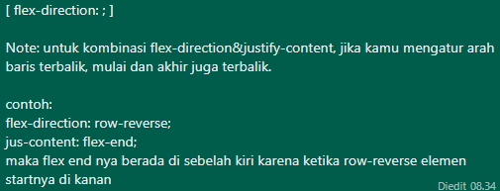Additional Note

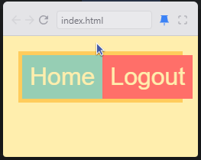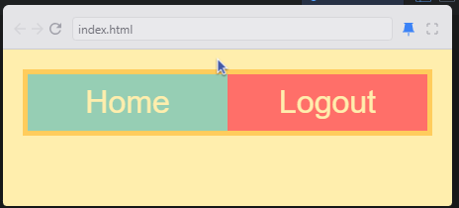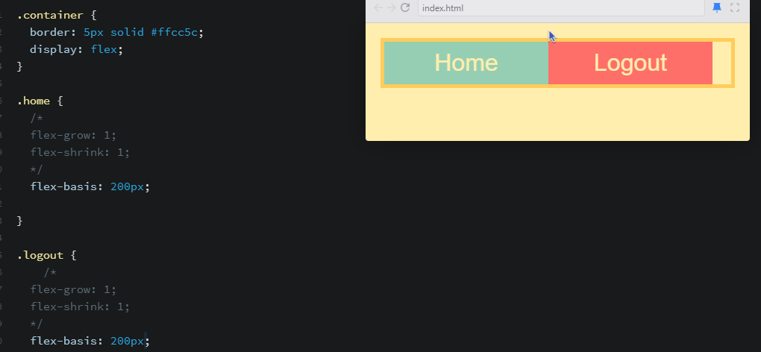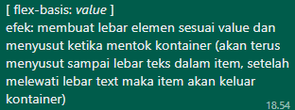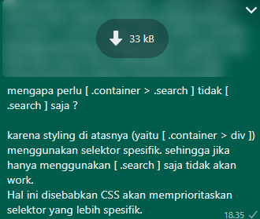

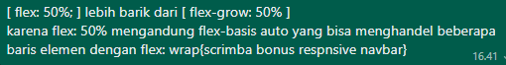

C. Assignment (Latihan)

1. Theodinproject > Foundations > Project > Alignment > Assignment (yang terakhir dari github)
2. Scrimba > Flexbox > Bonus
3. [www.developer.mozilla.org/en-US/docs/Learn/CSS/CSS_layout/Flexbox_skills](http://www.developer.mozilla.org/en-US/docs/Learn/CSS/CSS_layout/Flexbox_skills)